 

**INSTITUTE FOR ADVANCED COMPUTING ANDSOFTWARE DEVELOPMENT (IACSD), AKURDI, PUNE**

Documentation On

FitLife ProActive Gym

PG-DAC March 2023

# Submitted By:

**Group No: 112**

**Roll No. Name:**

**233197 Sahil Jaiswal**

**233174 Nikhil Rajput**

# Mr. Narendra Pawar Mr. Rohit Puranik

**Project Guide Centre Coordinator**

# ABSTRACT

This project is a Gym Portal and Management System for Gym web application is intended to provide complete solutions for owners as well as customers through a single get way using the internet. It allows owners to manage their gym, customer to view the packages provided by gym and booking their session online as per requirement. The administrator module will able to manage branch activity, gym activity, Gym activity, facility activity. and make it online which will be feasible and flexible and try to make it user friendly.

Gyms are become the essential part of our lives and providing best exercise.

In this application admin can manage the customer an easier and more convenient way. This project also maintains the Customer details, to provide the valuable reports regarding progress of the gym member. Admin can login with their username and password. Admin can add and update Gym details and work out details. Customer will register and login with their username and password. Customer can view exercise and work out timing details etc.

# ACKNOWLEDGEMENT

I take this occasion to thank God, almighty for blessing us with his grace and taking our endeavor to a successful culmination. I extend my sincere and heartfelt thanks to our esteemed guide,  **Mr. Narendra Pawar** for providing me with the right guidance and advice at the crucial juncture sand for showing me the right way. I extend my sincere thanks to our respected **Centre Co-Ordinator Mr. Rohit Puranik** , for allowing us to use the facilities available. I would like to thank the other faculty members also, at this occasion. Last but not the least, I would like to thank my friends and family for the support and encouragement they have given me during the course of our work.

#### Sahil Jaiswal (233197)

#### Nikhil Rajput (233174)

# Table of Contents

**ABSTRACT 1**

**ACKNOWLEDGEMENT 2**

**INTRODUCTION 6**

**FEATURES 6**

* 1. **PROJECT OBJECTIVE 7**
  2. **PROJECT OVERVIEW 7**

**Proposed Methodology...............................................................................................................5**

**Operating Environment...............................................................................................................6**

**Design and Implementation Constraints......................................................................................6**

1. **Requirements Specification....................................................................................................7**

**External Interface Requirements................................................................................................7**

1. **System Diagram........................................................................................................................8**

**Activity Diagram........................................................................................................................8**

**Data Flow Diagram....................................................................................................................9**

**Class Diagram...........................................................................................................................11**

**Use Case Diagram ....................................................................................................................12**

**ER Diagram ..............................................................................................................................13**

**5. Table Structure........................................................................................................................ 21**

**User ..........................................................................................................................................21**

**Manager....................................................................................................................................21**

**Batch… ....................................................................................................................................21**

**Trainer ......................................................................................................................................22**

**Member…………….................................................................................................................22**

**Branch………………...............................................................................................................22**

**Packages………………............................................................................................................23**

**Payment……………….............................................................................................................23**

**Report………………................................................................................................................23**

**6.Screenshots……………………………………………………………………………………...24**

**7. Conclusion............................................................................................................................32**

**Future Scope .......................................................................................................................32**

**8. References ...........................................................................................................................33**

**LIST OF FIGURES**

#### FIGURE 1: ACTIVITY DIAGRAM 13

**FIGURE 2: 0 LEVEL DFD 14**

#### FIGURE 3: 1 LEVEL DFD 15

**FIGURE 4: 2 LEVEL DFD FOR User OWNER 16**

**FIGURE 5: E-R DIAGRAM 17**

#### FIGURE 6: CLASS DIAGRAM 18

**FIGURE : TABLE STRUCTURE 21**

**FIGURE : PROJECT DIAGRAMS 25**

# INTRODUCTION

This project is a Gym Portal and Management System for Gym web application is intended to provide complete solutions for owners as well as customers through a single get way using the internet. It allows owners to manage their gym, customer to view the packages provided by gym and booking their session online as per requirement. The administrator module will able to manage branch activity, gym activity, Gym activity, facility activity. and make it online which will be feasible and flexible and try to make it user friendly.

This document communicates the business requirements and scope for developing Gym Service for a company. The scope of this document is to define the functional and non- functional requirements, business rules and other constraints requirements.Now a day’s online service is the best competitive edge for any organization. Our fitness management website provides best platform for ease of access to the gym managers, Gyms and also for customers. User can check his updates online anytime about his/her fitness, diet plan etc. There is a need for online healthcare maintenance online. This project provides user friendly customer and Gym interaction.

## Features: -

1. Separate login for Admin owner and Member.
2. Easy to add or update the user owner information by Admin.
3. Easy to generate Packages for each User by Admin.
4. Admin can easily circulate the notice from anywhere location through the system.
5. Date and time of visitor visited for specific User is autogenerated.
6. Easy to keep update of Gym.
7. Admin can assign User to owner and add him/her in Gym members by assigning access to the system.

## PROJECT OBJECTIVE

The This product aimed toward a person who don’t want to visit the gym to see functionalities and packages provided by that gym to get membership, he/she can use the web application for ease.

## PROJECT OVERVIEW

The application This system brings ease in the communication and business of B2C field. It provides the complete functionality to owner This system allows gym managers to manage users and full application, manage gym shifts and the members to search gyms, apply for membership and view workouts while it allows Gym to create schedule, diet chart.This product aimed toward a person who don’t want to visit the gym to see functionalities and packages provided by that gym to get membership, he/she can use the web application for ease

Admin gives limited access of this system to User owner and security guard. The data related with the User details and its owner stored by Admin on database through system. Admin is able to generate maintenance bill of a User which can be viewed by that User owner only. Admin circulates the notice using the system and this notice can be viewed by all User owners. User owner may add tenant for his/her User and can save tenants details on database through the system. User owner may raise the complaint through the system which can be viewed and solved by Admin and its status get changed from pending to completed. User owner can add his vehicle details on database through the system.

## PROJECT SCOPE

This system provides friendly user interface to every member of the Gym. The various other functionalities about Cross browsing, various languages suitable for different caste, etc. This application will help all sectors of people which will provide them visibility and smooth functioning. This will be beneficial to all the members who travel abroad and who cannot be a part of each and every notice of the Gym. This application will travel worldwide and any members will have an access to it. Understanding the needs of the Gym members and to overcome the manual work of the documentation and make it online which will be feasible and flexible and try to make it user friendly. Web-platform means that the system will be available for access 24/7 except when there is a temporary server issue which is expected to be minimal.

**3.SYSTEM REQUIREMENTS SPECIFICATION.**

**External Interface Requirements:**

User Interfaces:

All the users will see the same page when they enter in this website. This page asks the users a username and a password.

After being authenticated by correct username and password, user will be redirect to their corresponding profile where they can do various activities.

The user interface will be simple and consistence, using terminology commonly understood by intended users of the system. The system will have simple interface, consistence with standard interface, to eliminate need for user training of infrequent users.

Hardware Interfaces:

No extra hardware interfaces are needed.

The system will use the standard hardware and data communication resources.

This includes, but not limited to, general network connection at the server/hosting site, network server and network management tools.

Application Interfaces:

**Web Browser:**

The system is a web-based application; clients need a modern web browser such as Mozilla Firebox, Internet Explorer, Opera, and Chrome. The computer must have an Internet connection in order to be able to access the system.

Communications Interfaces:

This system uses communication resources which includes but not limited to, HTTP protocol for communication with the web browser and web server and TCP/IP network protocol with HTTP protocol.

This application will communicate with the database that holds all the booking information. Users can contact with server side through HTTP protocol by means of a function that is called HTTP Service. This function allows the application to use the data retrieved by server to fulfil the request fired by the us.

**HARDWARE REQUIREMENT**

Hardware requirements for insurance on internetwill be same for both parties which are as follows:

|  |  |
| --- | --- |
| **RAM** | 4 GB |
| **Hard disk** | 320 GB |
| **Processor** | Dual Core |

**Software Requirements**

**Client side:**

|  |  |
| --- | --- |
| **Web Browser** | Google Chrome or any compatible browser |
| **Operating System** | Windows 8 or above |

**Server side:**

|  |  |
| --- | --- |
| **Web Server** | To-be-decided |
| **Server-side Language** | J2EE(Spring, Hibernate) |
| **Database Server** | MYSQL |
| **Web Browser** | Google Chrome or any  compatible browser |
| **Operating System** | Windows 8 or above |

**OPERATING ENVIRONMENT:**

**Server Side:**

**Processor:** Intel® Xeon® processor 3500 series

**HDD:** Minimum 500GB Disk Space

**RAM:** Minimum 4GB

**OS:** Windows 10

**Database:** MySQL 8.0

**Client Side (minimum requirement):**

**Processor:** Intel Dual Core

**HDD:** Minimum 80GB Disk Space

**RAM:** Minimum 4GB

**OS:** Windows 7 or above

**Design and Implementation Constraints:**

The application will use ReactJS, Axios and CSS as main web technologies.

HTTP protocol is used as communication protocol. FTP is used to upload the web application in live domain and the client can access it via HTTP protocol. SMTP protocol is used for Email communication Several types of validations make this web application a secured one and SQL Injections can also be prevented. Since FitLife ProActive Gym is a web-based application, internet connection must be established.

**User Characteristics**:

User should be familiar with the terms like login, register etc.

**Principle Actors**:

Super admin, Gym Owners, Trainer, Members

**General Constraints**:

A full internet connection is required.

**Functional Requirements:**

This section provides requirement overview of the system. Various functional modules that can

be implemented by the system will be –

**1.Registration**

If customer wants to take the membership, then he/she must be registered, unregistered

user can’t have access to packages. They can view the gym.

The Super admin must be able to Register new gym branch details as well as the

Branch manager details.

The local gym branch owners can register new trainers for the gym.

**2.Login**

Each system user including Admin, Branch owners, Trainers and Customers/ Members must be able login to application by entering valid user id and password.

**3.Pakages**

Branch owners can provide different packages for customers.

Customer can view and packages, trainers and choose one as per their requirements.

**4.Membership**

After choosing one of packages & making successful payment customer can avail the services provided by gym.

**5.Gym Shifts**

Branch owners can schedule different shifts for group of customers and trainers.

**6.Workout plan**

Trainers can add workout plans and diet suggestions to their respective members.

**7.LogOut**

Application user redirected to home page after surfing the application or whenever they wanted.

**Non-Functional Requirements:**

**Security:**

System will assign different roles to users for authentication. Users will be allowed

to access application only after authentication by entering login id and password.

**Reliability & Maintainability:**

FCS will backup the users data after every activity using database.

**Availability:**

24X7 availability.

**Modularity:**

FCS will be designed and developed using independent or dependent business scenarios in the form of module It will contain modules such as Authentication, Package information, Branch Information, Trainers and customers data, Payment processing and Membership

**Reusability:**

The different modules of system will be reusable and can be modified independently.

**Scalability:**

System will be able to provide consistent user experience to users.

**FIGURES:**

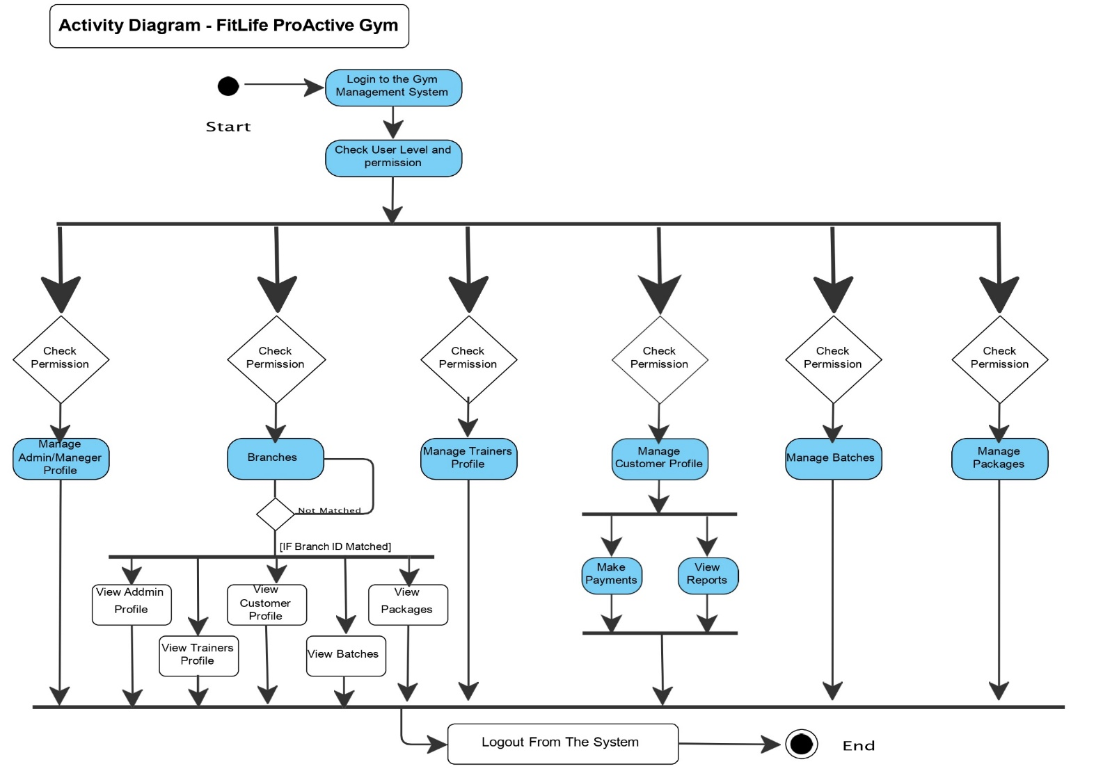

### Figure 1 Activity Diagram

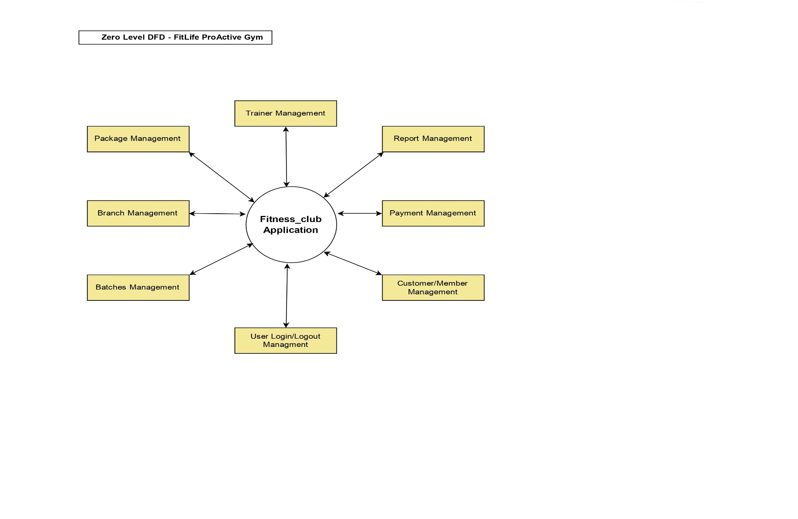

### Figure 2 Zero Level DFD

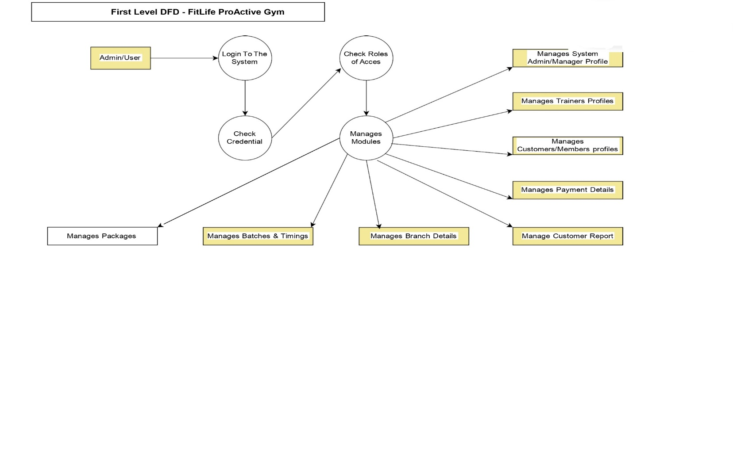

*Figure 3 First Level DFD*

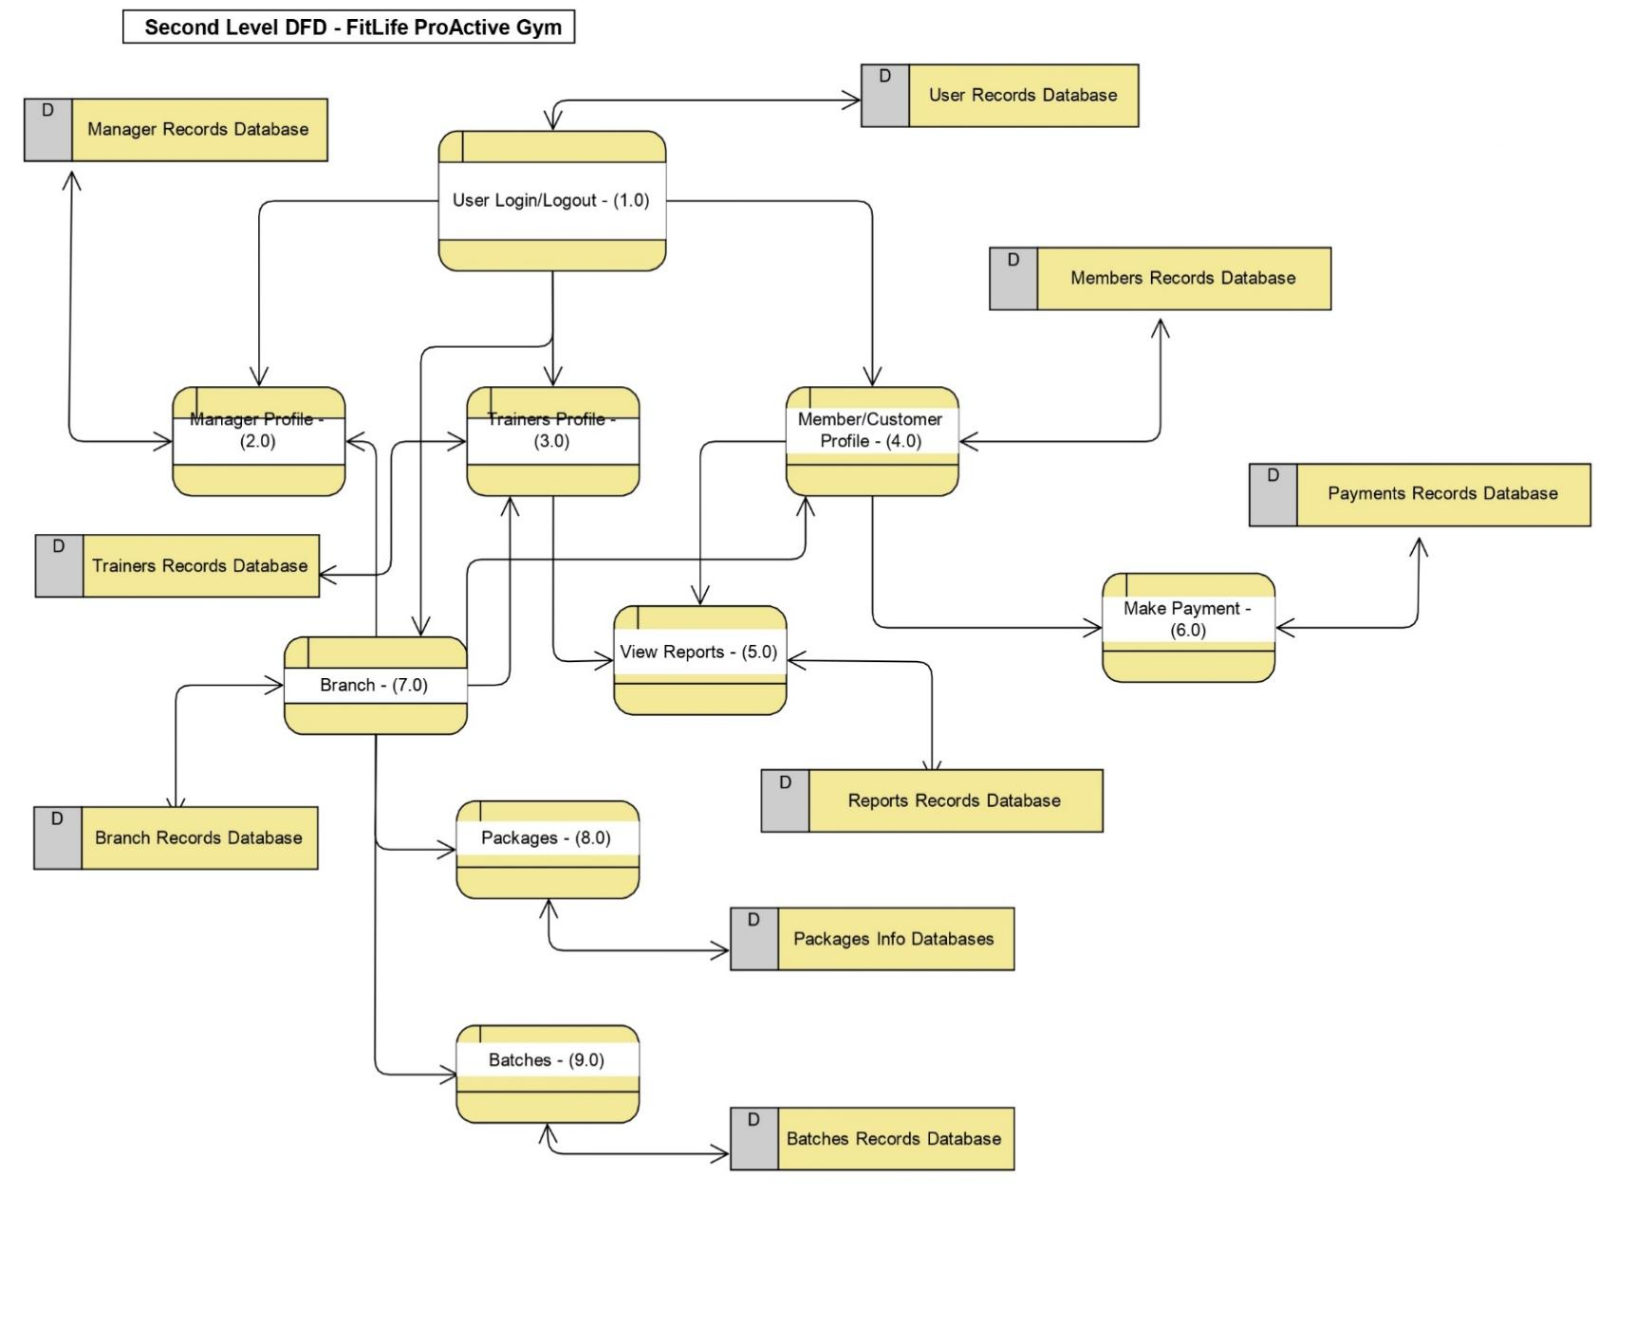

*Figure 4 Second Level DFD*

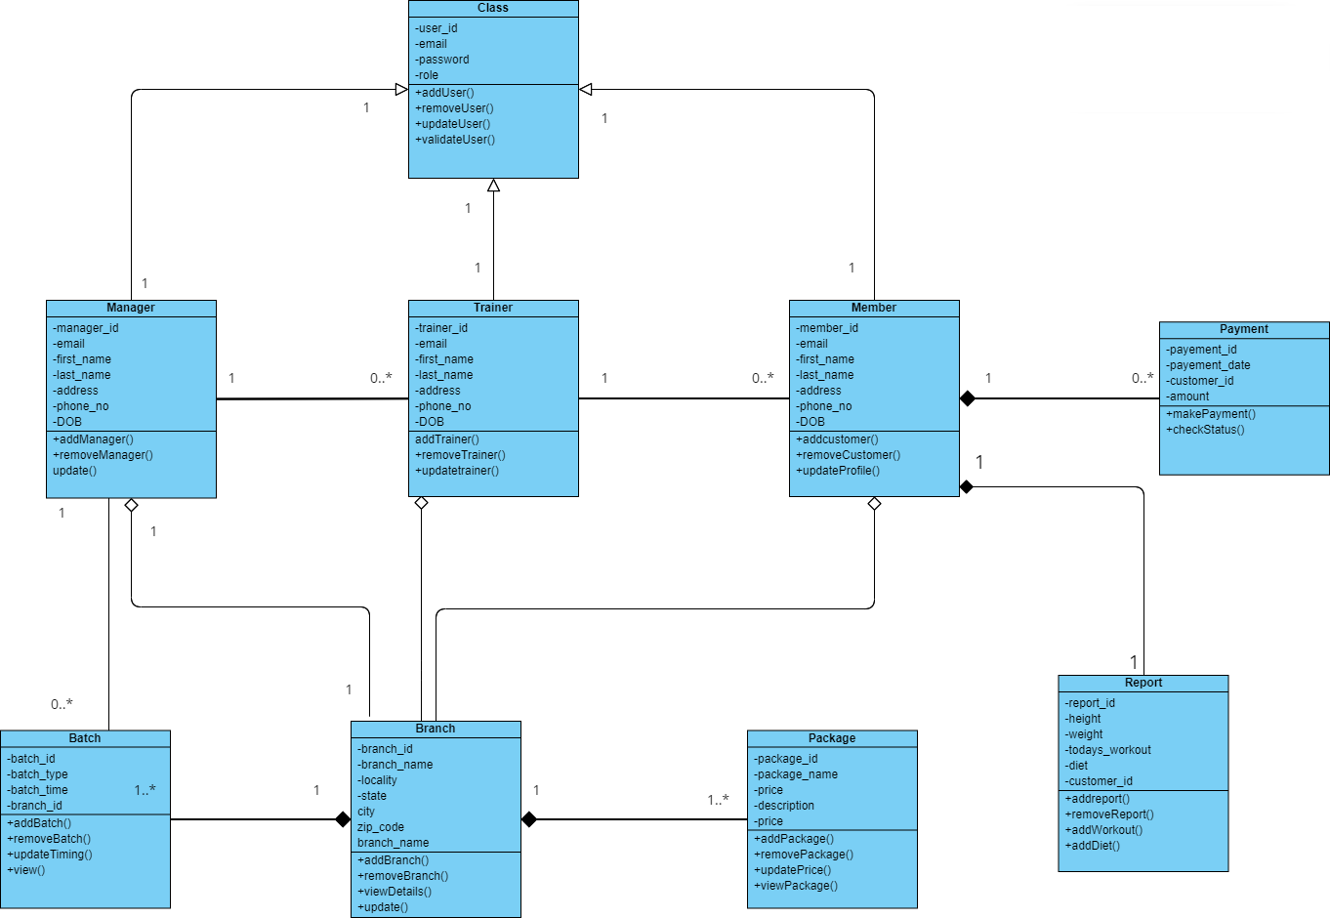

*Figure 5 Class Diagram*

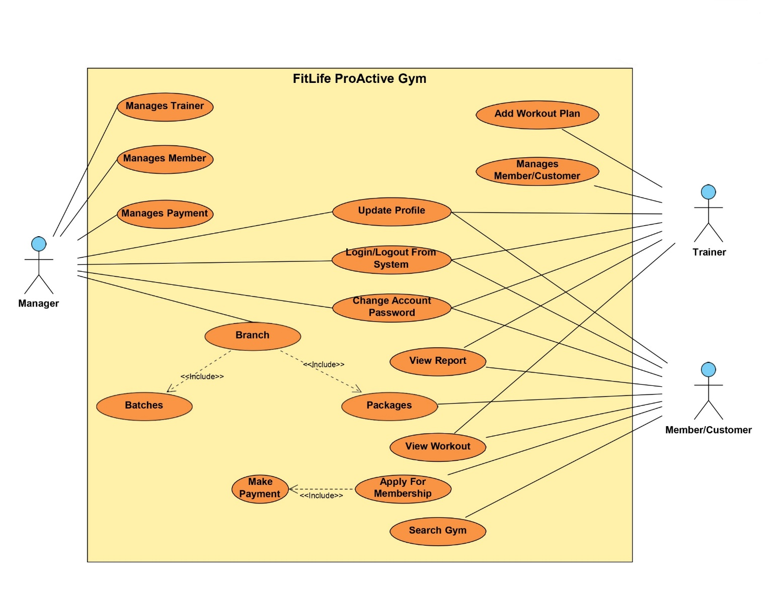

*Figure 6 User Case Diagram*

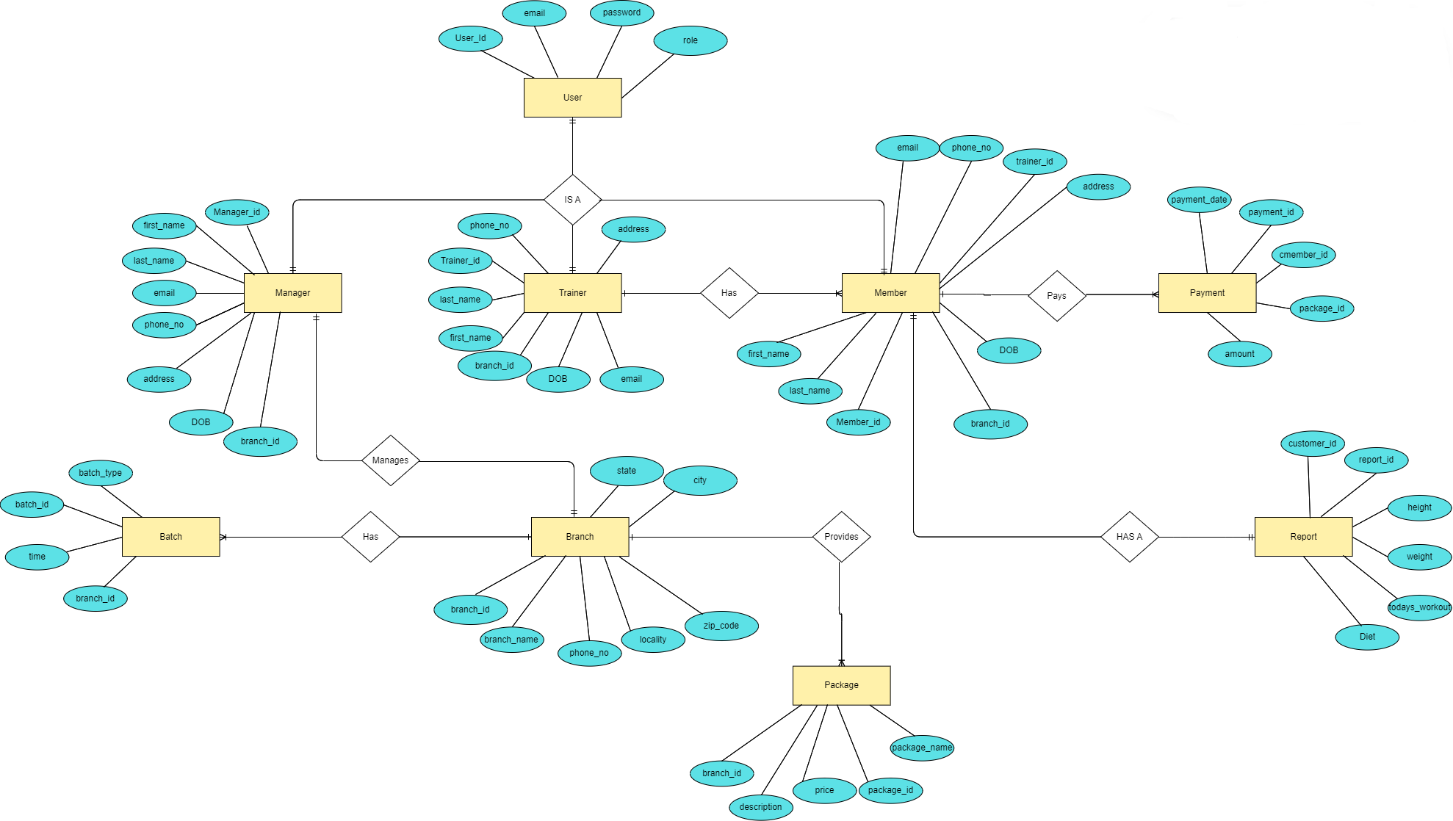

*Figure 7 ER Diagram*

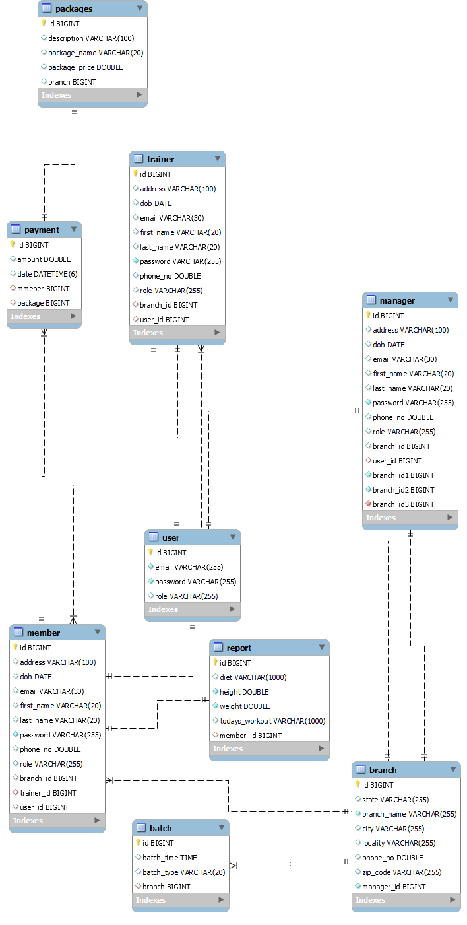

*Figure 8 System Generated ER Diagram*

## Table Structure

User:

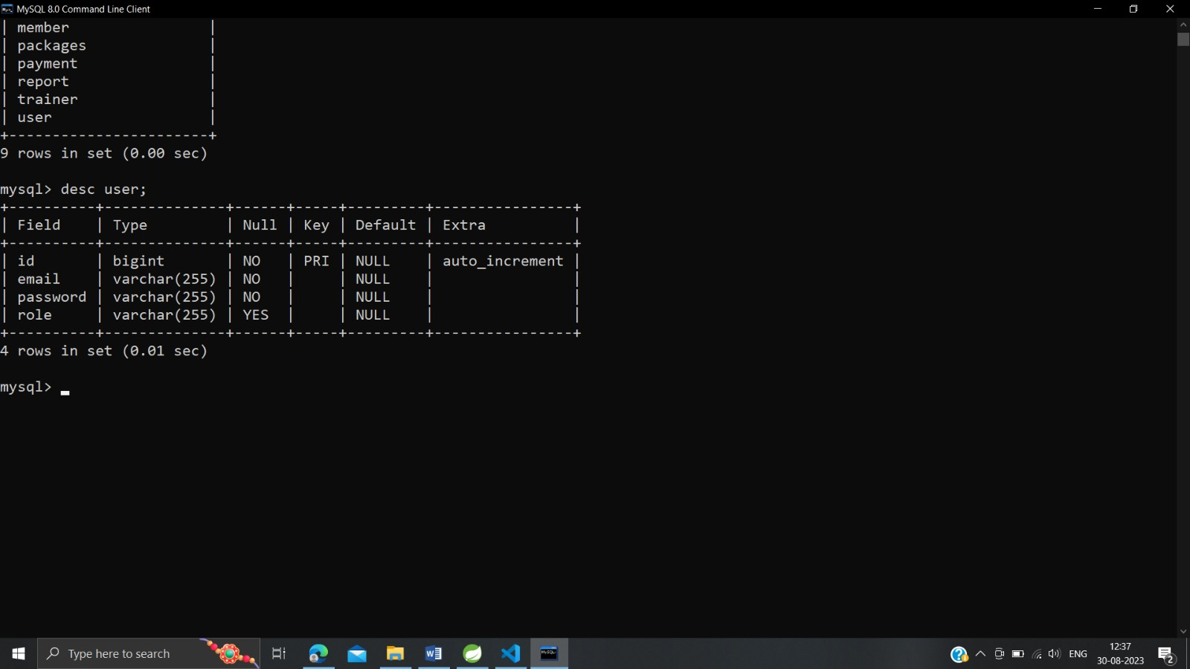

## Manager:

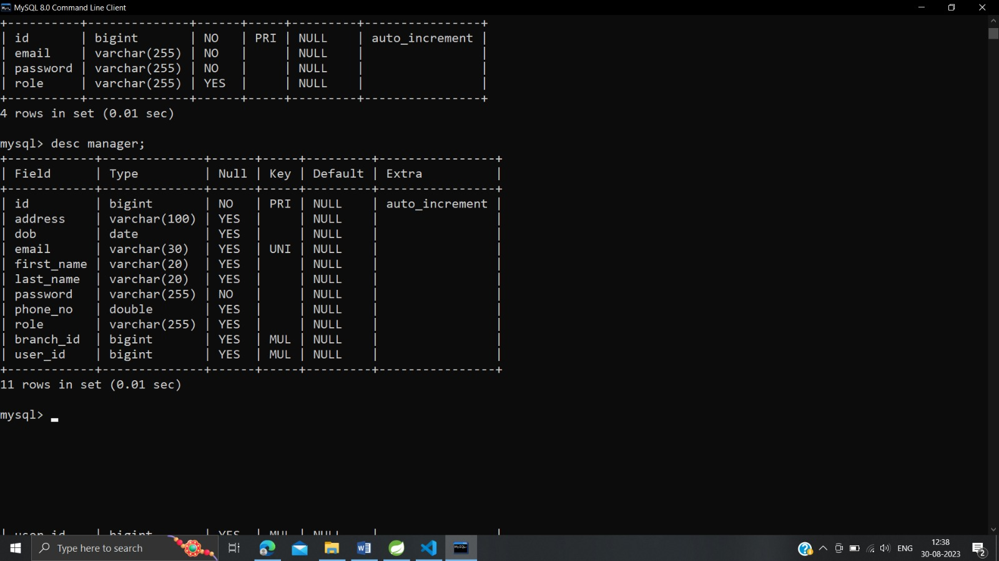

## Batch:

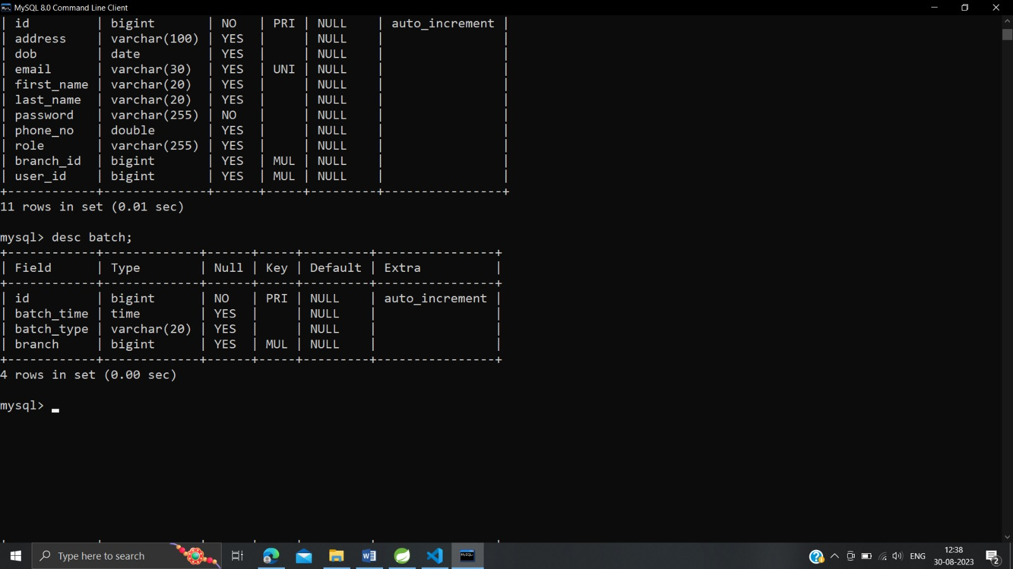

## Trainer:

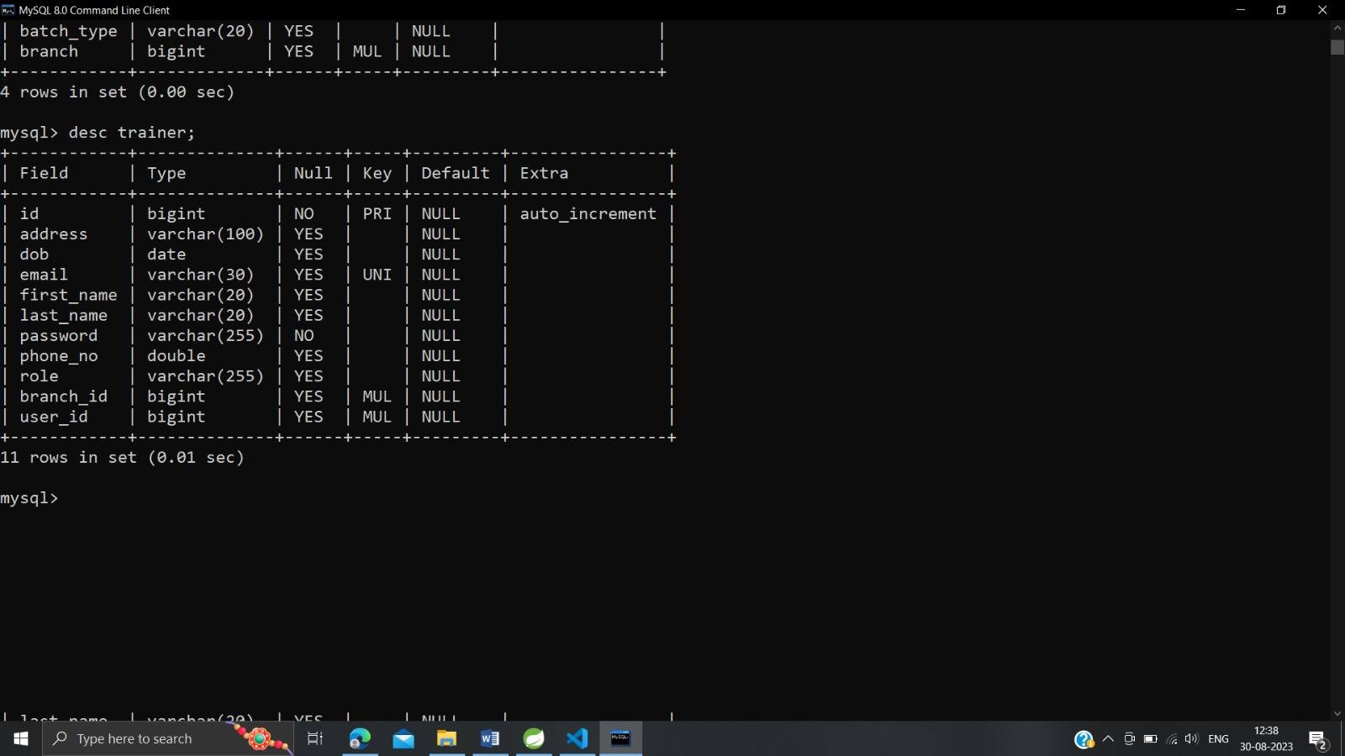

## Member:

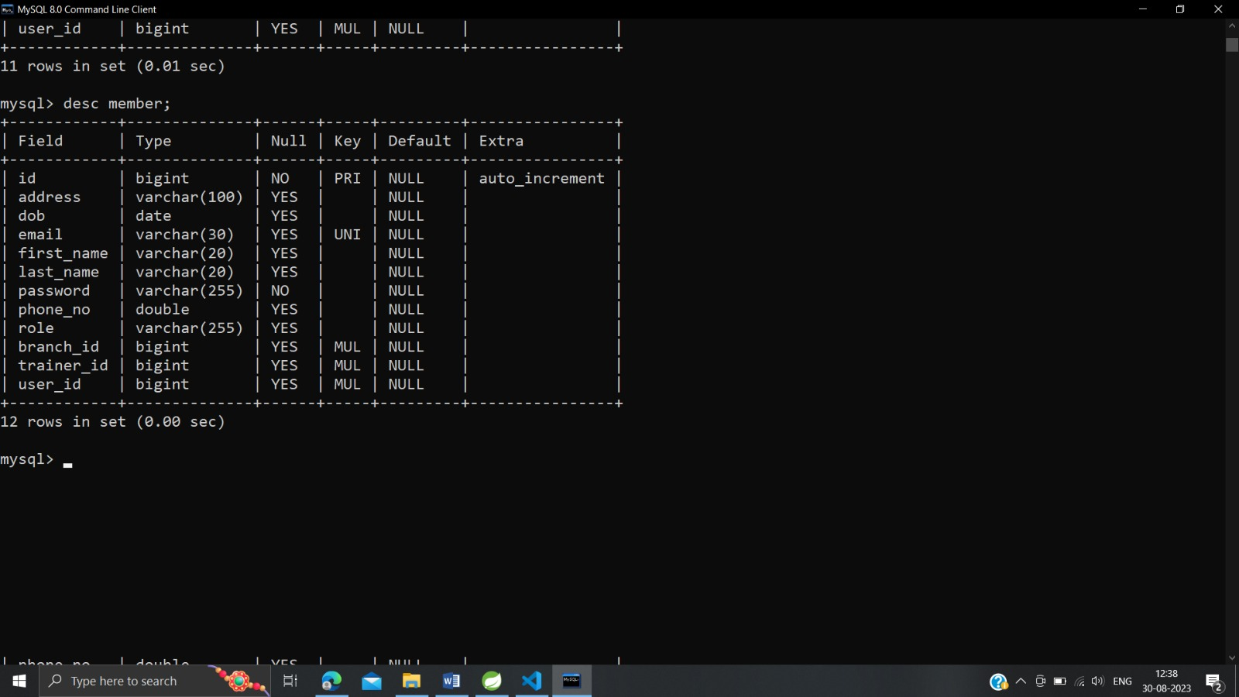

## Branch:

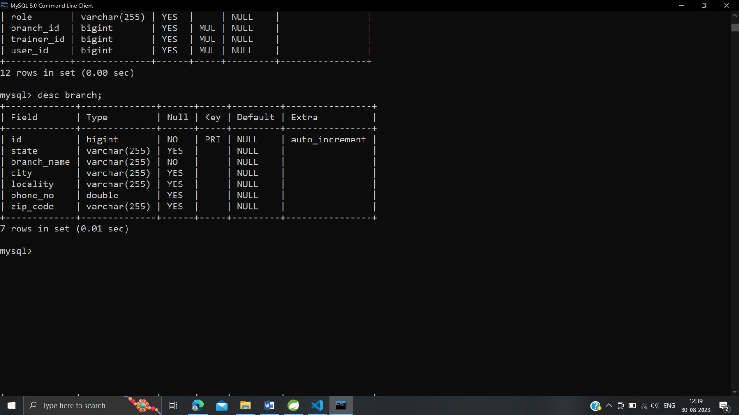

## Package:

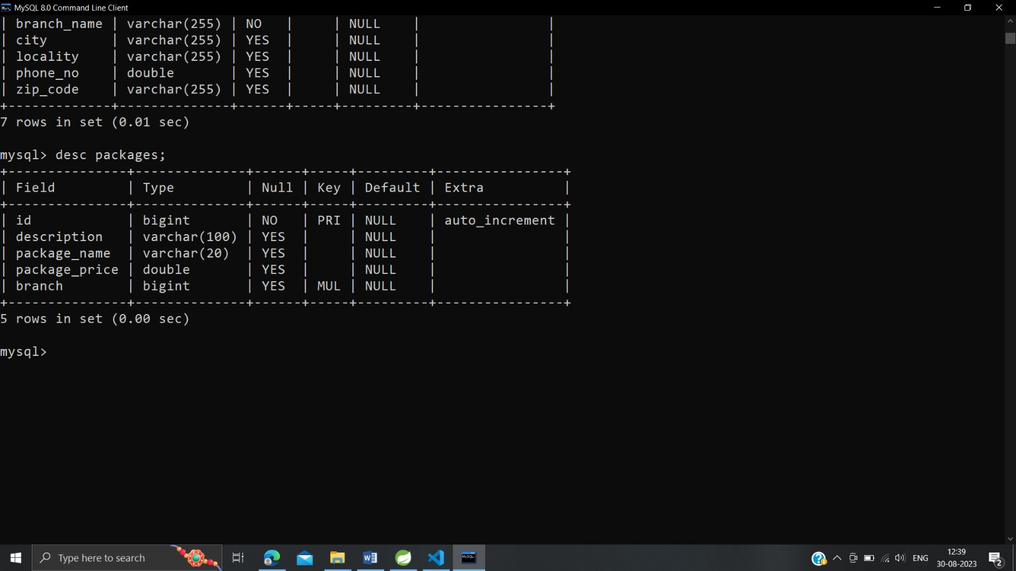

## Payment:

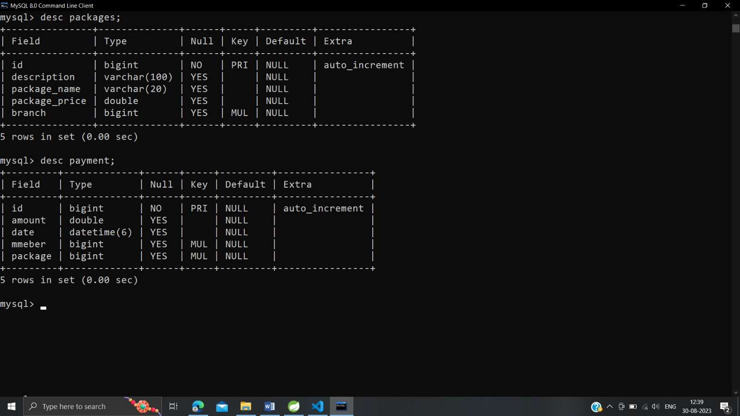

## Report:

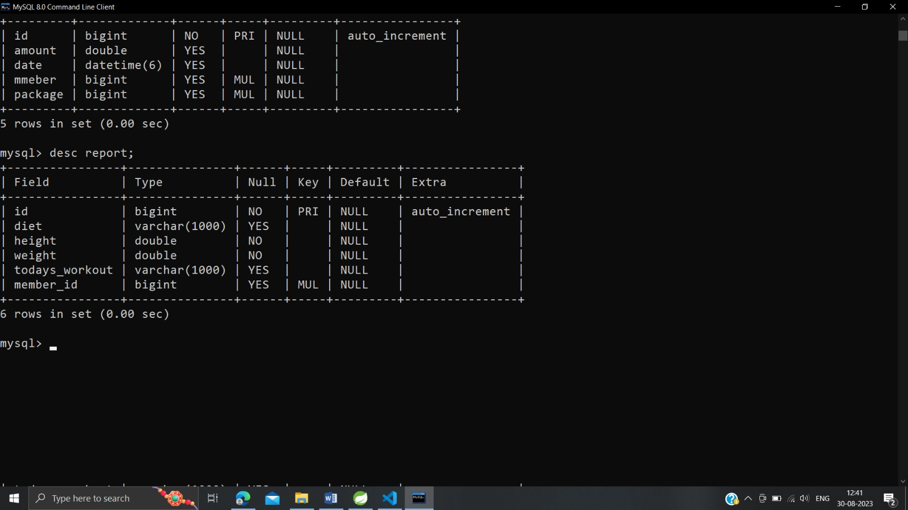

# SCREENSHOTS

## Homepage:

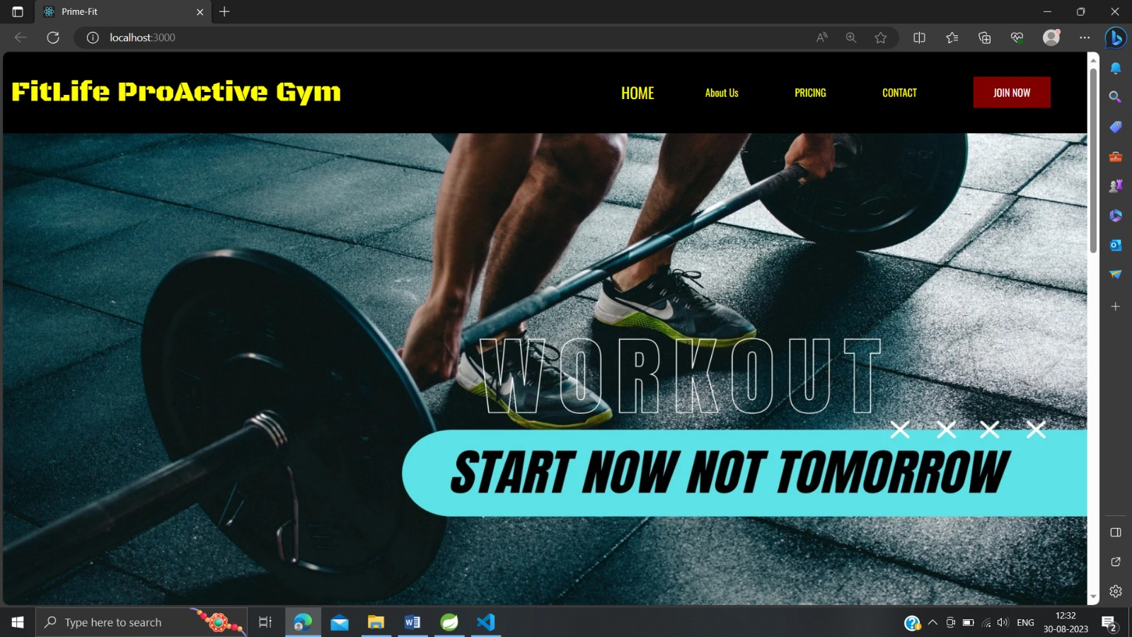

## Sign in/Sign up Page:

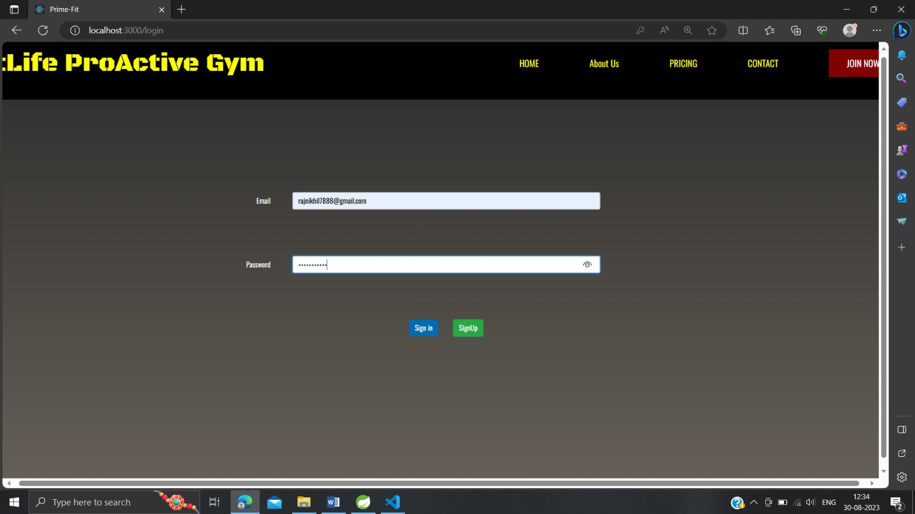

## Admin Page:



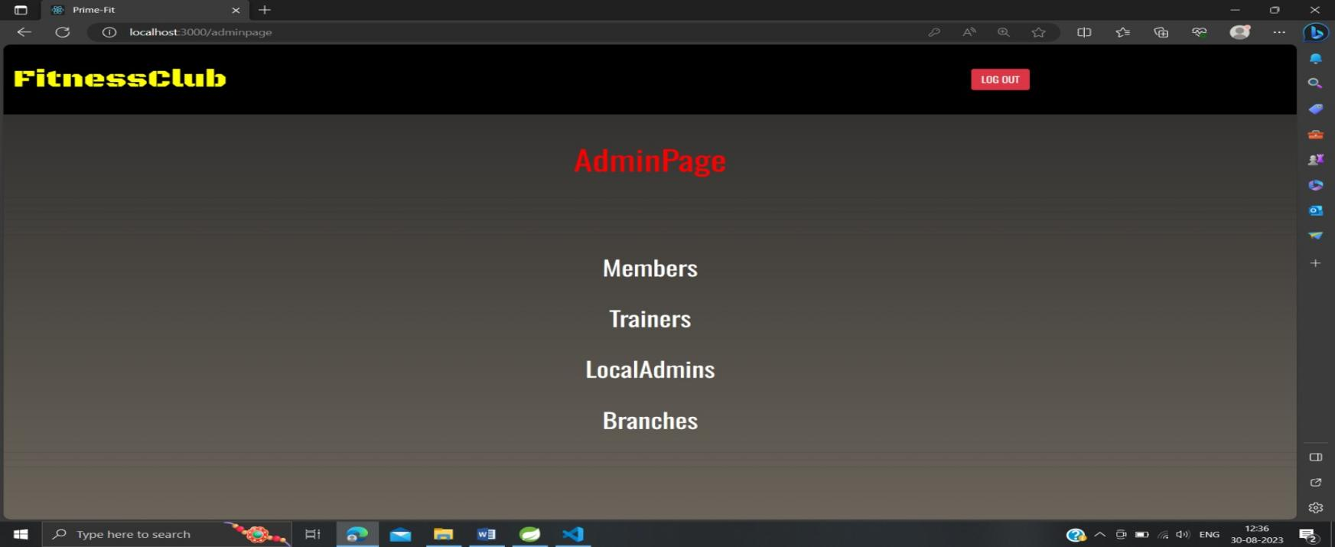

## All Branches:



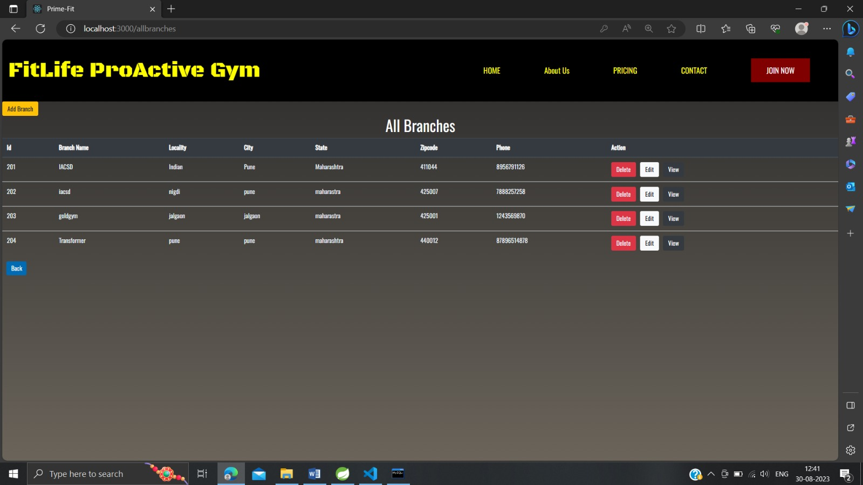

## Add Branch Form:



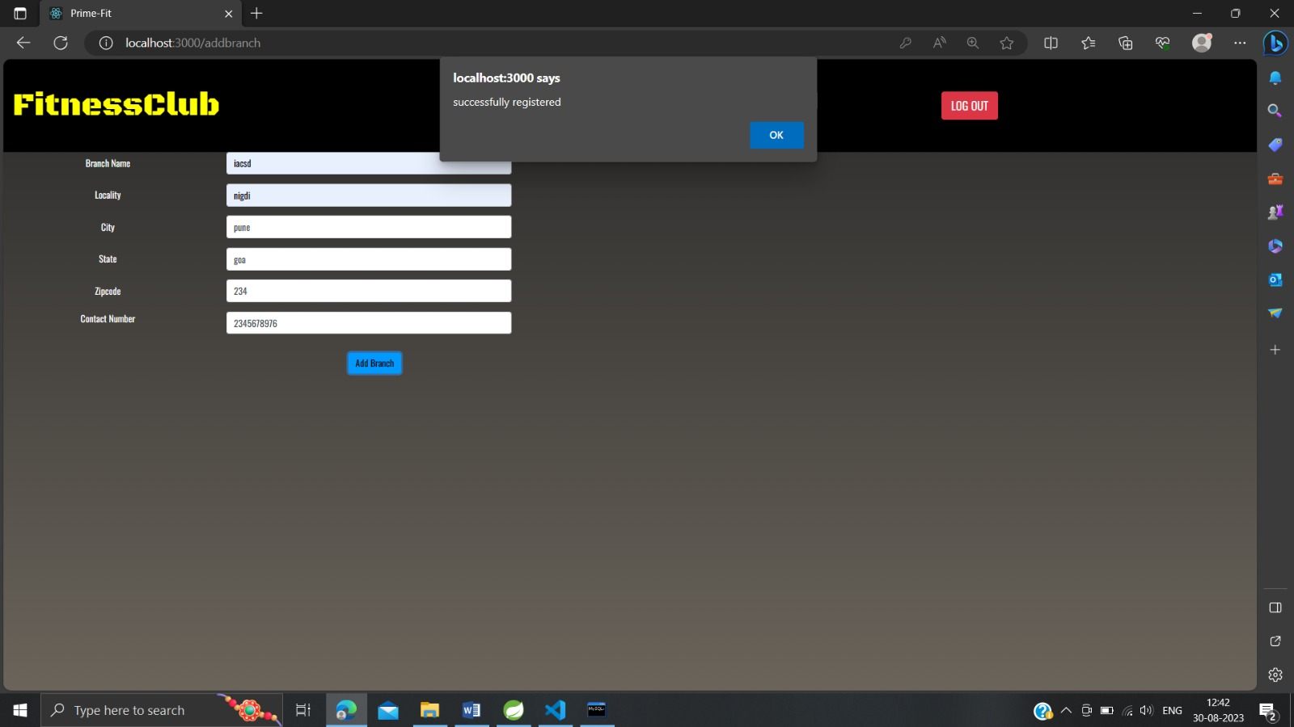

## Manager Branch Page:

  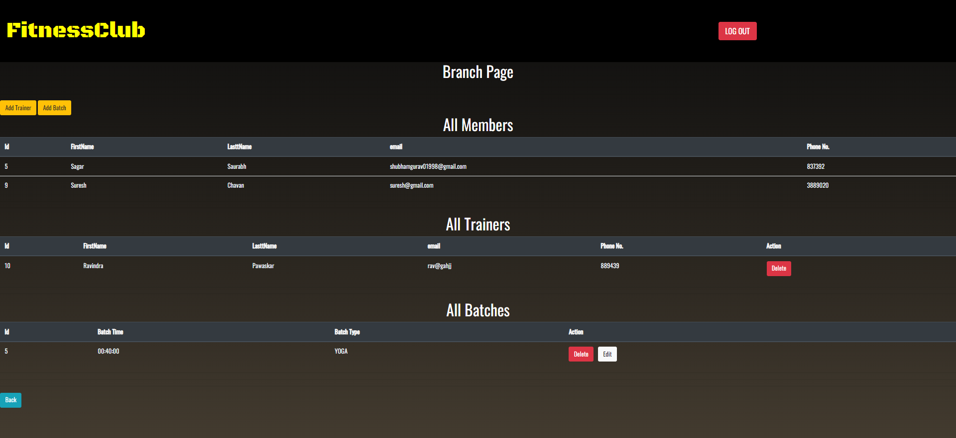

## Trainer Add Page:

  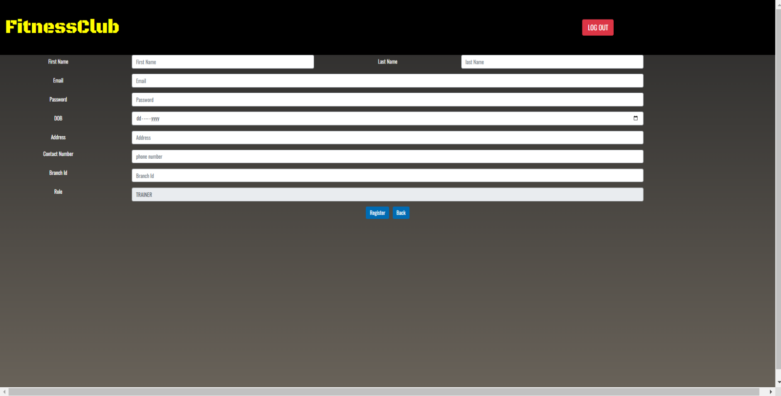

## Gym Shift Page:



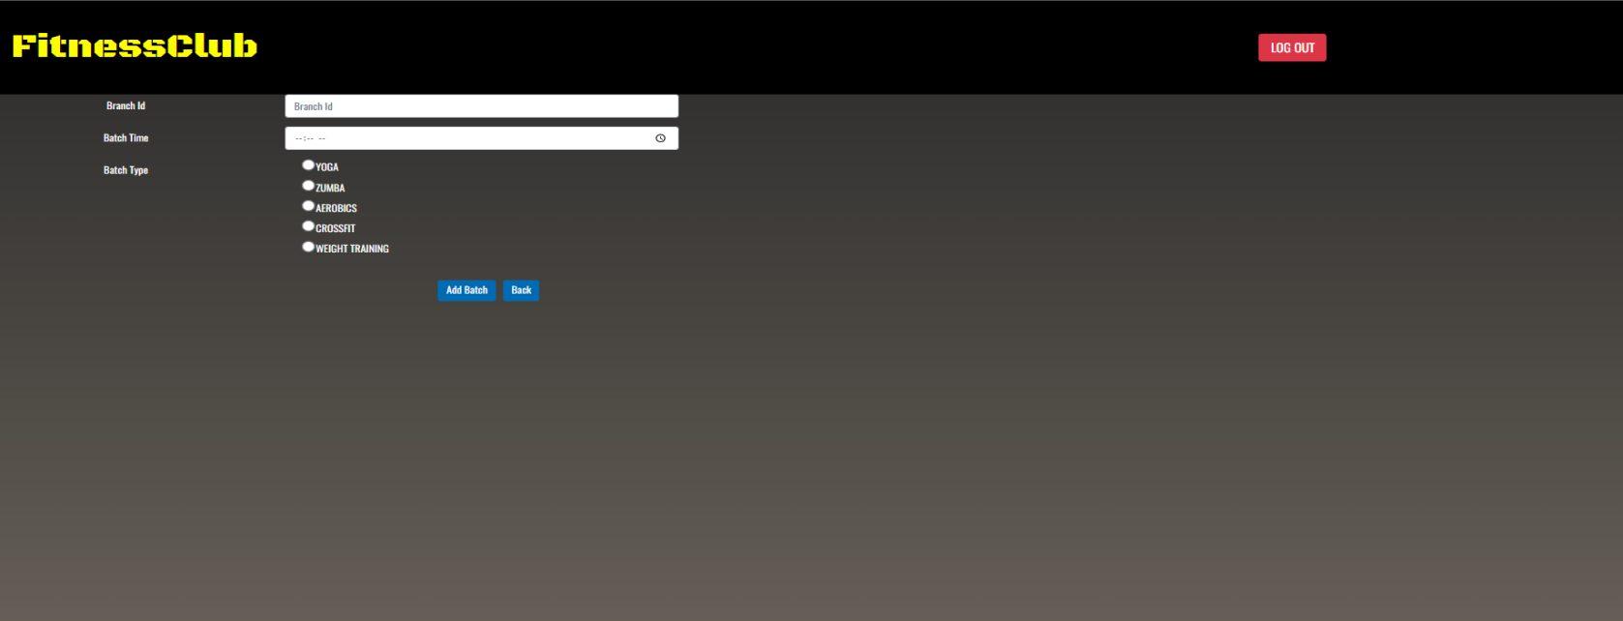

## Add New Package:



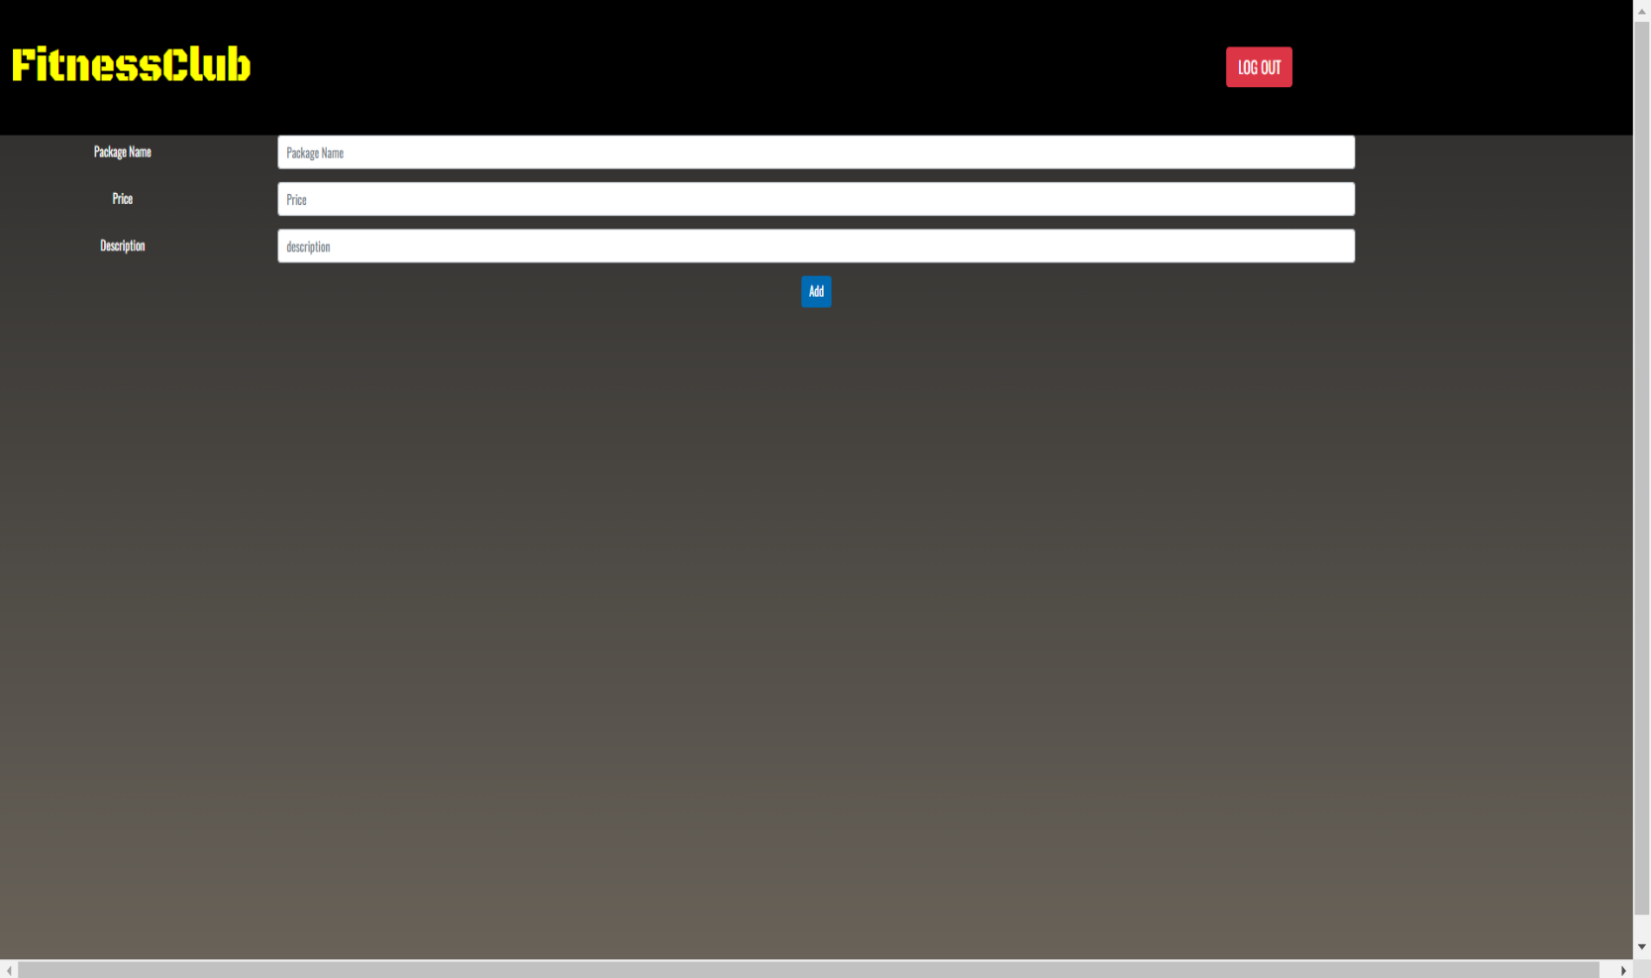

## Purchase MemberShip:

  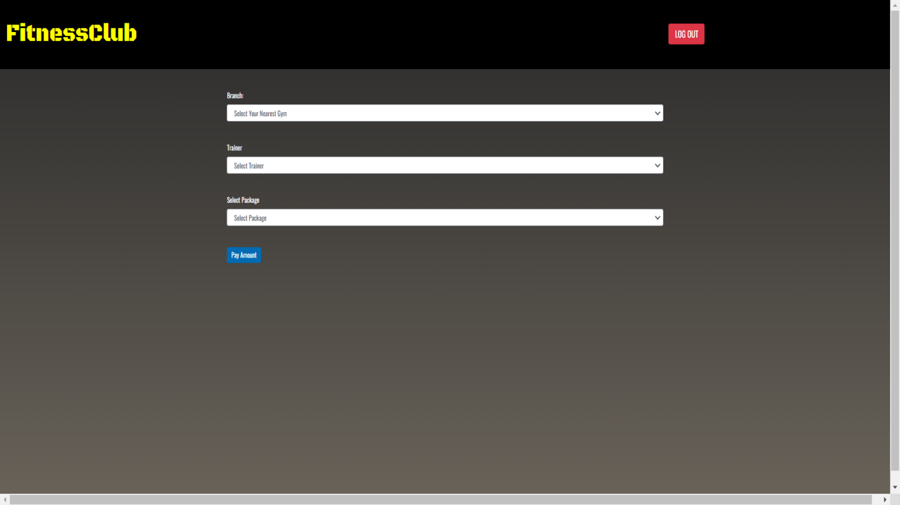

## Workout Report:

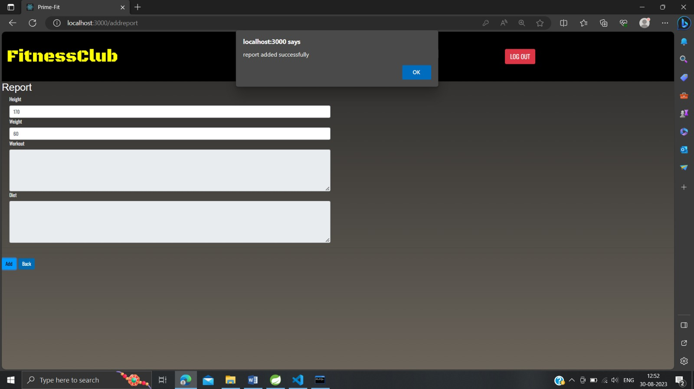

**ABOUT US:**

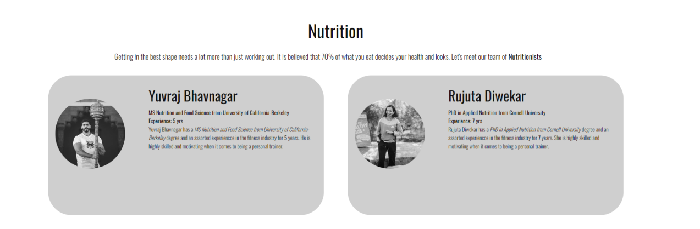

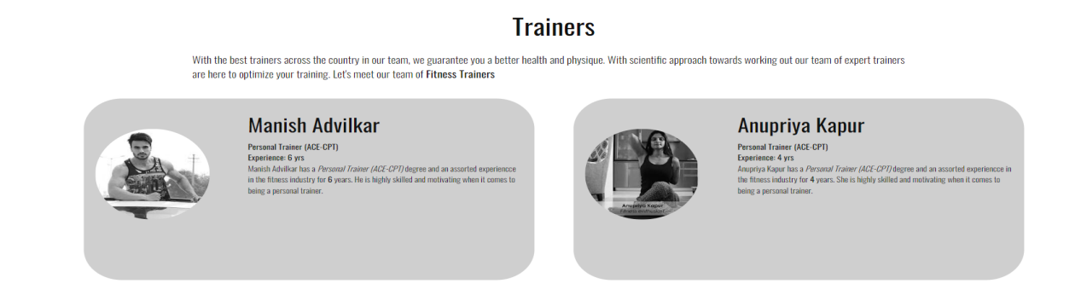

**PASSWORD ENCRYPTION:**

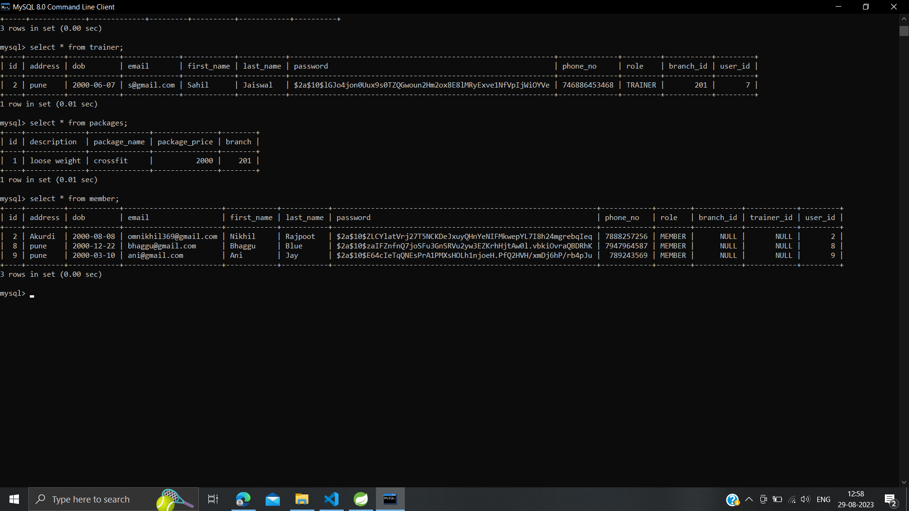

**CONCLUSION**

This system brings ease in the communication and business of B2C field. It provides the complete functionality owner This system allows admin to manage users and full application, manage gym shifts and the members to search gyms, apply for membership and view workouts while it allows trainer to create schedule, diet chart and add workout plans.

This system provides opportunity to Gym owners to expand their business online. Saves time and efforts of customers to right gym and reduces overall paper work of managing records and registers. Customers and Trainers can receive notifications via email.

**Future Scope:**

This project can be enhanced further by adding payment gateway to reduce the maintenance of cash for Membership purchase payments. Online Workout tutorials and online Expert sessions can be hosted on this site for better customer satisfaction. The software is flexible enough to be modified and implemented as per future requirements. We have tried our best to present this free and user–friendly website to Institutes.

